Children’s party food

The City Farm Café is the trading arm of Windmill Hill City Farm, providing high quality catering to the community rooms here. Everything we do is designed to reflect and support the ethos of the charity, and all our profits help support the educational and social work the Farm does. Our menu is constantly changing, but you can always find the best produce at the core of our dishes. The Farm has a strong environmental policy, and we play our part by using great local produce, some of it from our own doorstep and recycling most of the waste we produce, including adding to the Farm’s compost heaps daily. Our menus are vegetarian, in line with our sustainability policy. See our website for more supplier information.
We’ve made it simple to order by having flexible options, to which you can add extras as required. Unless otherwise requested, food is served buffet style on platters for children to help themselves. We provide plates, napkins and cutlery where appropriate.
Please complete all the details below, including any dietary requirements or allergies we need to know about.
Date of booking: _______________ Lead contact:__________________
Arrival time: ___________________ Contact number:________________
Room booked: _________________ Food to be served at: ___________

Allergies & dietary requirements
Please note, unless you request otherwise, 50% vegetarian and 50% vegan, but can vary these to suit your group.
All items will be labelled with the 14 most common allergens as required by law.

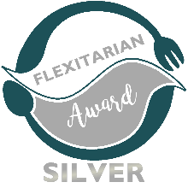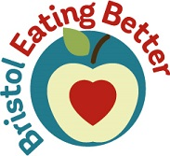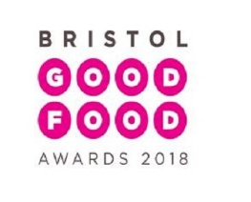
Hot Drinks for grown-ups | Per head | Quantity | Total  price
Selection of breakfast tea, filter coffee and organic herbal teas, served with organic dairy milk (oat or soya milk available on request)  Half Day Hot Drink Selection | £2.00
Full Day Hot Drink Selection | £3.60
Please note: There is a wider selection of hot & cold drinks available in the café which can be provided on request. Guests are also welcome to order from the café and take drinks to the booked room. We are happy to set up a tab if you prefer.

Sandwich party platters | Per head | Quantity | Total price
Includes: | £5.95
Mini Sandwiches-
Cheddar (v)
Hummus (vg)
EggMayo (v)
Mini Sweet Potato & Black-eyed bean roll (vg)
Organix Crunchy Carrot Sticks (vg)
Apple Juice
Please specify sandwich fillings choice here:

Children’s Party Extras | Per head | Quantity | Total price
Dips: Hummus (vg) | £1.50
Herby Cream Cheese (v) | £1.50
Includes fresh vegetable sticks & bread sticks

Flapjack Bites (vg) | £1.30
Brownie Bites (v) | £1.60
 |  | Total

